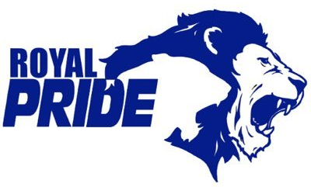
Ridgetown District High School
9 Harold Street N.
Ridgetown, ON
519-674-5449

Recommended School Supplies

Parents and Guardians,
Below is a list of recommended schools supplies for the upcoming school year. Feel free to send all at once or as needed. Students are able to store extra supplies in their locker.
School Supplies

1 - 2” binder
1 package dividers
Lined paper
Pens
Pencils
Eraser
Scissors
Glue Stick
Pencil crayons (basic colours)
Markers (basic colours)
2 Dry Erase Markers
Scientific Calculator
Basic Geometry Set
Ruler
Pencil Case

Additional Items

Change of clothes for gym
Gym shoes
Headphones
Water Bottle
Pencil Case

If you have any questions or concerns, please contact the school using the information listed above.
GO ROYALS!

