January Newsletter 2021

Harvest Fresh
At this point in the school year, Harvest Fresh will not be able to operate in the school. If you still have money in your Harvest Fresh account, please contact them directly to get your money back. Their phone number is 226-774-6001. They also have a contact form on their website at harvest-fresh.ca.

Photo day
Our school photo day has been scheduled for January 25. There will be new protocols in place to follow Covid-19 guidelines within the building.

Sleds/Shovels
The FDK classes are always looking for more sleds/shovels for the students to play in the snow with. If you have any that are collecting dust in your house and are willing to part with them, we would have some very grateful kindergarten students!

Inclement Weather and our Bus Zone 6
Winter often brings snow and ice which result in poor visibility and icy conditions. Please listen to Radio CKSY or CFCO or 99.1 between 7 & 8 AM to see if buses are running in Zone 6. Some of our students live in Zone 5. If buses are not operating in Zone 6, they will not be picking up students in Zone 5 or 6. If Zone 5 is closed, buses will not go into that Zone to pick up students. There is also the Bus Info APP available through our board’s web page.

Virtual School Council Meeting
Our next School Council Meeting is scheduled for Tuesday, January 26th at 6:30PM. Currently, all School Council Meetings are being held virtually. If you are interested in joining our next meeting, please contact the office to get added to the list and receive the meeting link.

Change in the Weather
With the changing weather, please ensure that your children are dressed appropriately with hats, boots, mittens, etc. Students play outside, most days, for 2-twenty minute recesses, so please dress for the weather.

Items For Sale
The school will be selling DACS Eagles water bottles and masks. Masks will be $8 and water bottles will be $7. These are available to be purchased through School Cash Online, or through the office via the attached order form. First come first served. View on the school website to see colours of items.

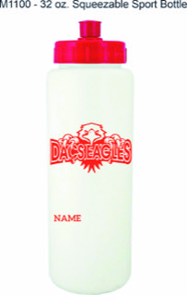

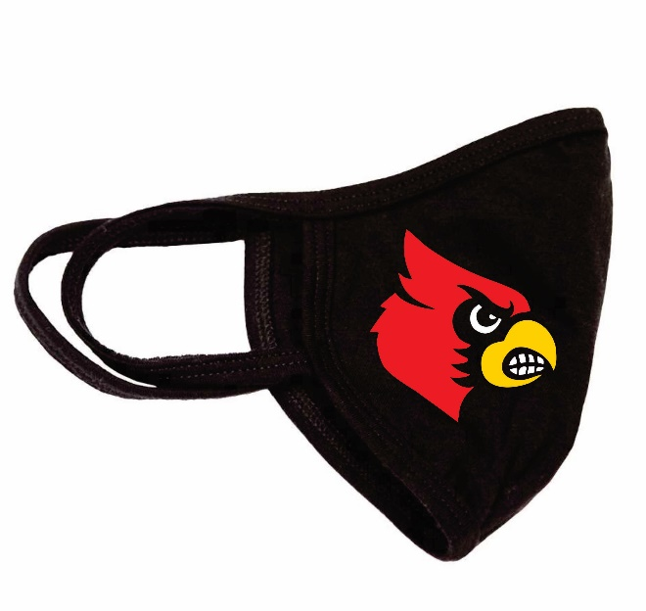

Automated safe arrival calls
Effective January 11, Lambton Kent District School Board will be implementing an automated attendance messaging system for Dresden Area Central School. The system will notify parents/guardians if your child has been marked absent and the school office has not been notified of the reason for the absence.
The system will contact the first 2 contacts on file, ie parent/guardian phone numbers and email addresses.
You can help by ensuring that the school has been called to inform of us the reason for your child’s absence, also, if your child is NOT a bus student, on snow or fog days, call the school to let us know they will be at home, etc.
Your most updated contact information should be on file so please call us to update as needed.
Please note: School voicemail messages are checked regularly.

Daily COVID-19 Screening Tool
Thank you to our parents/guardians for assessing your child(ren) daily and reporting whether they are experiencing any signs of illness. Please refer to the Ontario screening tool https://covid-19.ontario.ca/schoolscreening/ . The screening tool will advise you whether you should send your child(ren) to school or not and will also advise you of next steps. All students who are experiencing symptoms consistent with COVID-19 must not attend school and should seek appropriate medical attention as required.

Visitors to the School
You must have a pre-arranged appointment to enter the school. Currently, due to COVID-19 restrictions, there are no visitors permitted in the school. When you arrive to pick up or drop off your child(ren), or for any other reason, buzz the office at the main door and we will assist you when you arrive.

Moving Between Learn at Home and Face-to-Face Instruction
There will be more opportunities to switch program type during the year and families wishing to transfer must contact their principal according to the following timelines:
• Winter date: Families notify school by January 12 at noon. Student begins new program type on February 3.
• Spring date: Families notify school by March 30. Student begins new program type on April 20

Face Masks/Coverings
Please send extra masks with your child. We have several requests daily for a mask and we only have a very limited supply.
Extra in backpacks will be helpful.

Report Cards
Our first term report cards will be sent home on Thursday, February 19th. These report cards will cover areas of achievement, growth and areas to focus on for the remainder of the year.
KinderSTARt
On Thursday, February 4th from 4pm to 7pm and Friday, February 5th from 9am to 3pm, we will be accepting registrations for new students to Full Day Kindergarten. Typically, this would be for children turning 4 in 2021. You are kindly asked to bring your child’s birth certificate and proof of address (usually a utility bill, rent receipt, income tax form with the parent(s)/guardian(s) name). This is a great opportunity for parents and children to learn more about school together. Through KinderSTARt children and parents have an early opportunity to visit the school and meet staff in preparation for Full Day Kindergarten in the fall of 2021. Appointments will be booked on-line in 30 minute intervals to ensure all Covid precautions can be met. Please register for your time using the link below:

Registering your child for Kindergarten is as easy as 1, 2, 3.
- Find your school
- Complete the online registration form @ www.lkdsb.net/kindergarten
- Sign-up for a visit to meet our amazing staff!
https://www.signupgenius.com/go/904054EA9A62DA4FA7-kinderstart
Remember to bring:
- Birth certificate or proof of Canadian Citizenship or Residency Status (if appropriate)
- Proof of residency (e.g. utility or tax bill, lease/rental agreement, etc.)
- Your child

Important Dates

January 25: Photo Day
Feb 4-5: KinderSTARt registration
Feb 5: PA Day
Feb 15: Family Day
Feb 19: Report cards go home
Feb 24: Photo retakes and Gr. 8 Grad portraits

