December Newsletter 2020

Welcome
We would like to welcome Mrs. K. McCabe to our staff. We look forward to seeing the amazing things Mrs. McCabe will be doing with our students this year.

Inclement Weather and our Bus Zone 6
Winter often brings snow and ice which result in poor visibility and icy conditions. Please listen to Radio CKSY or CFCO or 99.1 between 7 & 8 AM to see if buses are running in Zone 6. Some of our students live in Zone 5. If buses are not operating in Zone 6, they will not be picking up students in Zone 5 or 6. If Zone 5 is closed, buses will not go into that Zone to pick up students. There is also the Bus Info APP available through our board’s web page.

Virtual School Council Meeting
Our next School Council Meeting is scheduled for Tuesday, December 8th.
Currently, all School Council Meetings are being held virtually. If you are interested in joining our next meeting, please contact the office to get added to the list and receive the meeting link.

Change in the Weather
With the changing weather, please ensure that your children are dressed appropriately with hats, boots, mittens, etc. Students play outside, most days, for 2-twenty minute recesses, so please dress for the weather.

Items For Sale
The school will be selling DACS Eagles water bottles and masks. Masks will be $8 and water bottles will be $7. These are available to be purchased through School Cash Online, or through the office via the attached order form. First come first served. View on the school website to see colours of items.

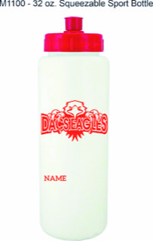

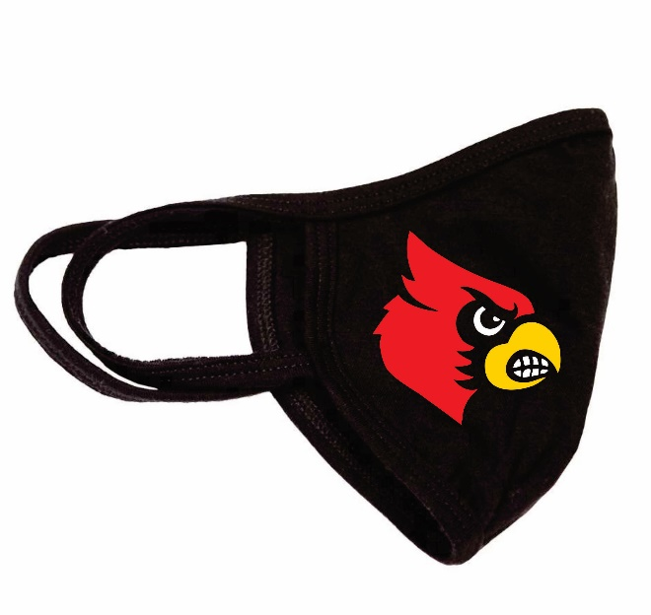

Automated safe arrival calls
Effective December 8, Lambton Kent District School Board will be implementing an automated attendance messaging system for Dresden Area Central School. The system will notify parents/guardians if your child has been marked absent and the school office has not been notified of the reason for the absence.
The system will contact the first 2 contacts on file, ie parent/guardian phone numbers and email addresses.
You can help by ensuring that the school has been called to inform of us the reason for your child’s absence, also, if your child is NOT a bus student, on snow or fog days, call the school to let us know they will be at home, etc.
Your most updated contact information should be on file so please call us to update as needed.
Please note: School voicemail messages are checked regularly.

Daily COVID-19 Screening Tool
Thank you to our parents/guardians for assessing your child(ren) daily and reporting whether they are experiencing any signs of illness. Please refer to the Ontario screening tool https://covid-19.ontario.ca/schoolscreening/ . The screening tool will advise you whether you should send your child(ren) to school or not and will also advise you of next steps. All students who are experiencing symptoms consistent with COVID-19 must not attend school and should seek appropriate medical attention as required.

Visitors to the School
You must have a pre-arranged appointment to enter the school. Currently, due to COVID-19 restrictions, there are no visitors permitted in the school. When you arrive to pick up or drop off your child(ren), or for any other reason, buzz the office at the main door and we will assist you when you arrive.

Holiday Break
The last day before the Holiday Break is December 18th and classes will resume again on Monday, January 4th, 2021. On behalf of the entire Dresden Area Central School Staff, we wish our students and their families a wonderful and healthy holiday. Continue to stay safe and see you in 2021!

Moving Between Learn at Home and Face-to-Face Instruction
There will be more opportunities to switch program type during the year and families wishing to transfer must contact their principal according to the following timelines:
• Winter date: Families notify school by January 12. Student begins new program type on February 3.
• Spring date: Families notify school by March 30. Student begins new program type on April 20

Face Masks/Coverings
Please send extra masks with your child. We have several requests daily for a mask and we only have a very limited supply.
Extra in backpacks will be helpful.

Important Dates

Dec 8: Virtual School Council- 6:30
Dec 18: Last day of classes
Dec 21-January 1: Christmas Break
January 4: Classes resume

