Colonel Cameron News | Principal ~ Mrs. K. Myers  Secretary ~ Ms. S. Codling  Tel: 519-862-1116  Fax: 519-862-4655
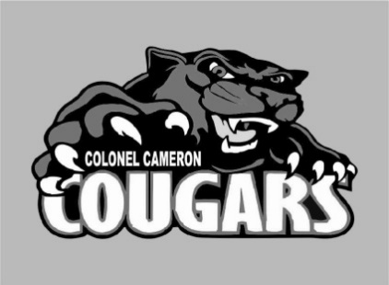

October 2020
Hello Cougar Family! This year has been a start-up unlike any other. I want you to know that we appreciate your understanding as directions change. Know that first and foremost in the minds of our staff is the education and well-being of our students. If you have any questions or concerns, please don’t hesitate to call and ask or email me at Kathy.myers@lkdsb.net.

School Screening
Please continue to use the online screening tool each day for your child before they come to school. A link to the screener is available on the board website. We want to do our part to ensure the safety of everyone at Colonel Cameron.

Halloween
Colonel Cameron will be celebrating Halloween with Black and Orange day on Friday, Oct 30. Treats are not necessary but if you must send them, please remember that we cannot have ANY homemade treats this year. All treats must be prepackaged, individually wrapped and nut free. Homemade treats will be sent back home.

Parent Council
Parent Council will be having an online meeting on 20 October at 4PM. If you would like to join us, please let the office know so that we can send you the invitation to the Google Meet. Parent council is always looking for some fresh faces with fresh ideas!

Parking/Drop Off

Thanks for being so diligent about parking in the parking lot if you are leaving your vehicle. This allows for quick movement of cars that are just dropping off and allows cars that are moving through the ability to see students that might be walking in the lanes. We appreciate you helping to keep your students and their friends safe.

Important Up-coming Dates:
Oct. 12 - Thanksgiving (No School)
Oct. 20 - School Council Meeting
Nov. 20 – PA Day
Dec. 21-Jan 3 – Christmas Holidays
Feb. 2 – PA Day (Note this is a Tuesday)
Feb. 15 – Family Day (No School)
Mar 15-19 – March Break
April 2- Good Friday
April 5 – Easter Monday

Visit the Facebook page, “Colonel Cameron PS- Parent Council” for updates on great things happening at our school!

