Colonel Cameron News | Principal ~ K. Myers  Secretary ~ Ms. S. Codling  Tel: 519-862-1116  Fax: 519-862-4655
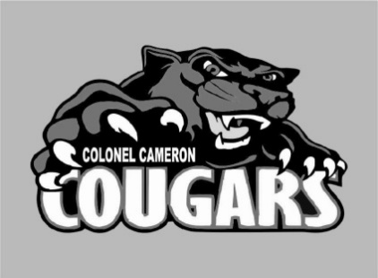
November 2019

Progress Reports/Communication of Learning
Progress Reports for Grades 1 to 8 students and Kindergarten Communication of Learning Initial Observations for Kindergarten students will be sent home Friday, November 15. Grades 1 to 8 Progress Reports indicate how a child is progressing in the subjects covered to date. There are 3 categories: Progressing With Difficulty, Progressing Well, and Progressing Very Well. Progressing With Difficulty means that a child will require improvement and/or assistance to meet the provincial standard at the end of the term/year. Progressing Well means that there is evidence that a child is meeting or will meet the provincial standard by the end of the term/year. Progressing Very Well means that there is very consistent evidence that a child is meeting or will meet, or is exceeding or will exceed, the provincial standard. In all three categories, teachers use their professional judgment and knowledge of the individual child to make a final determination.

Attendance/Late Letters with Progress Reports
Research indicates that the more days a child is absent from school, the greater the impact is on his or her academic achievement. The expectation laid out by the ministry is that students should not miss more than 20 days per year (2 days/month). Students who have been absent 5 days or more will receive an attendance letter to accompany the Elementary Progress Report Card. LKDSB has administrative procedures in place and can provide support through a referral to the LKDSB Attendance Officer to help families get students here on time and every day.

Student/Parent/Teacher Conferences
Conferences for students will take place Thursday, November 21 from 3:30-7:30 p.m. and Friday, November 22 from 9:00-12:00 p.m. This is an opportunity for you to view your child’s work, show interest in your child’s accomplishments and give your child encouragement for further growth. Details for booking a conference will be sent home soon.

Treaties Recognition Week, November 4-8
​As we approach Treaties Recognition Week in the first week of November, schools are working toward greater understanding of treaties, treaty relationships, and the responsibilities we have to raise awareness about Indigenous histories, cultures, contributions and perspectives. Most of our teachers have received training in order to lead our school toward greater understanding as part of our commitment to implementing the recommendations of the Truth and Reconciliation Commissions Call to Action in Education. Although we highlight Treaties Recognition Week each November, daily we strive to adhere to our responsibilities. Our teaching, our learning, and our daily Traditional Territorial Acknowledgement, are all important components of our responsibilities to raise awareness.

Remembrance Day Assembly
A special assembly has been organized by Mr. Steeves and students to honour and remember those brave individuals who fought for our country. Please join us at 11:40 a.m. on November 11, in our school gymnasium for our assembly. Poppies will be provided for the students and as usual we will be accepting monetary donations for the Royal Canadian Legion to support their cause.

Bullying Awareness and Prevention Week
Ontario has designated November 19-23 as Bullying Awareness and Prevention Week to help promote safe schools and a positive learning environment.
Bullying is defined as a form of repeated, persistent and aggressive behaviour directed at an individual or individuals that is intended to cause (or should be known to cause) fear and distress and/or harm to another person's body, feelings, self-esteem or reputation. Bullying occurs in a context where there is a real or perceived power imbalance.
The different forms bullying include:
- Physical – hitting, shoving, stealing or damaging property
- Verbal – name calling, mocking, or making sexist, racist or homophobic comments
- Social – excluding others from a group or spreading gossip or rumours about them
- Electronic (commonly known as cyberbullying) – spreading rumours and hurtful comments through the use of cellphones, e-mail, text messaging and social networking sites

EQAO 2018-2019 Results
We are very proud of our students, teachers, support staff and parents for the ongoing efforts in helping students to achieve their academic potential. Our Grade 3 students had 59% of students meeting grade standards in reading, 41% in writing and 45% in math. Likewise, our Grade 6’s had 86% in reading, 82% in writing and 32% in math. We will continue to use this information as one of many measures to reflect on our instructional practices and implement teaching and learning strategies to benefit our students.

Parent Council News
Our MacMillan fundraiser was a great success with $2,349.60 in profit raised for the school. We will be keeping track of which class raises the most money during our fundraisers over the year and the class with the most money raised at the end of the year will get a pizza party. After our first fundraiser, Ms. Miller’s class is in the lead!
Next up is our Christmas wreath fundraiser coming up on November 15th 6-8pm. Students brought home registration forms that should be returned to the office. This will be followed up with our Deli Dude orders. Forms to be coming home in November with delivery date scheduled just in time for the Christmas holidays (December 18th). Also Mabel’s label has a new holiday collection available online which includes personalized gift tags, stocking stuffers, and return address stickers for your Christmas cards. Check out Mabel’s labels and help keep kids things out of the lost and found.

Important Dates
November 1 ….……… Little Caesars
November 4-8…….... Treaty Week
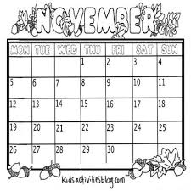
November 6……..……. Gr 4 Enrichment Testing
November 11…….….. Remembrance Day Assembly (11:40)
November 13……..….. Rocks and Rings Curling Activity
November 15…………. Report Cards go home
…….…Picture re-take day
……….Foodland Lunch
……....Wreath Making Night (Pre-registered only)
November 21-22 ..….. Parent/Teacher Interviews
November 25 …..…….. Bus Safety Presentations
November 29 …..…….. Boston Pizza Day
December 12 ……...….. School Council Meeting
December 23-Jan 5 … Christmas Holidays
January 31 ………………..PA Day
February 17 …….………..Family Day
March 14-22 ……….……March Break
April 10 ……………….….. Good Friday
April 13 …………..………..Easter Monday

