Colonel Cameron News | Principal ~ Mrs K. Myers  Secretary ~ Ms. S. Codling  Tel: 519-862-1116  Fax: 519-862-4655
January 2022
School Screening
Please continue to use the online screening tool each day for your child before they come to school. A link to the screener is available on the board website. Please note that if one child is waiting for the results of a COVID test or if one child fails the screener then none of the children in the family are to attend. We want to do our part to ensure the safety of everyone at Colonel Cameron.
For the first two weeks in January, parents will be asked to complete the same screener that we did in September. If the school does not receive the notice that you have completed the screener for your child, then we will be calling home each day for the 10 days.

Antigen Testing
Every student will be sent home with a box of 5 Antigen Testing kits. These are sent to families in the hopes that you will consider testing your child over the holidays and before returning to school to ensure that we are keeping everyone safe.

Kindergarten Registration
Registering your child for kindergarten is as easy as 1, 2, 3.
Follow the steps below to register a student in JK to Grade 8 who is new to LKDSB.
- Click here to find your local Public School and check on Bussing
- Sign up for an LKDSB Parent/Guardian account in our secure Aspen Student Information System and follow the steps to register an Elementary student who is NEW to LKDSB. This account is meant to be created by a Parent/Guardian. A valid e-mail address is required to verify your identity when requesting an account.
Click here for instructions on how to create an LKDSB - Aspen account. Once the account is created, you will be able to login to the LKDSB Online Registration process.
Click here to Login to LKDSB - Aspen or to Request an LKDSB - Aspen account to register your child
Call the school to make an appointment to visit your school to meet our caring staff and complete the registration process.
To complete your registration, remember to bring:
  - Birth certificate or proof of Canadian Citizenship or Residency Status (if appropriate)
  - Proof of Residency (e.g. utility or tax bill, a lease/rental agreement, a proof of ownership, landline phone bill, etc.)
  - Parent contact information, work and home phone, e-mail
  - Emergency contact information
Immunization Requirements - The Ministry of Education requires that every student have a complete and up-to-date immunization record on file with the local Health Unit in order to attend school. Contact Chatham-Kent Public Health or Lambton Public Health to ensure your immunization records are up-to-date.​

Picture Re-Take Day
Picture retake day is Jan 26. If you want your child to have their picture retaken, please make sure that you notify the teacher or the office.

School Cash Online
If you haven’t already registered for School Cash Online, please try to get this done as soon as you can. Fundraisers, school events and other events that require cash transactions will go through School Cash Online ONLY. If you need help setting it up, please let Ms. Codling know. Milk orders and food orders (Little Caesars’ – January 7th) are available online now. Pita Pit orders will open January 10th.

Food Days
Our next Food Day will be Little Caesar’s Pizza on January 7 For $2.00 they will get a slice of pizza individually packaged. The slice is from a medium pizza cut into 4 slices. This is only available through School Cash Online. More information about Pita Pit Lunches will be coming out in the new year. If you order and your student is away, please let us know what you would like us to do with the food as we can’t keep it at school.

Special thanks to Parkway Church, Nicole Smith from Riverview Realestate and Ashley Tidball from Corunna Chiropractic for helping us out with our Christmas Lunch for our students and staff. Thanks also to LaPier’s flowers for the gift card which we were able to put to good use. Did you know that Parkway Church offers a free hot lunch program once a month? The lunch is delivered right to your door. Anyone is welcome to take part. Simply request your lunch by emailing info@weareparkway.com. Please leave your name (first and/or last), phone number, address, and the number of lunches required.

Parent Council
Our next Parent Council meeting will be February 1, 2022. Please let the office know if you would like to be invited to the Google Meet.

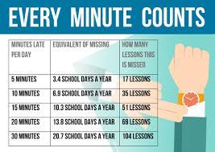
Important Up-coming Dates:
Jan 3 – First Day back from Holidays
Jan 7 – Little Caesar’s Pizza Lunch
Jan 26 – Picture Retake Day
Jan 28 – Pita Pit Lunch
Jan 31 – PA Day (**MONDAY**)
Feb 21 – Family Day (No School)
March 14-18 March Break
April 15- Good Friday (No School)
April 18 – Easter Monday (No School)
May 23 – Victoria Day (No School)
June 10 – PA Day
June 21 – Native Solidarity Day
June 28 – Last day of School
June 29 – PA Day

How to help with executive functioning at home
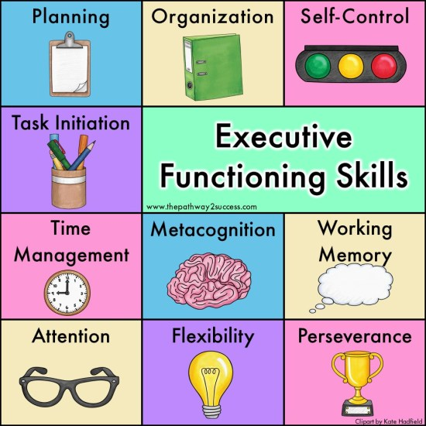
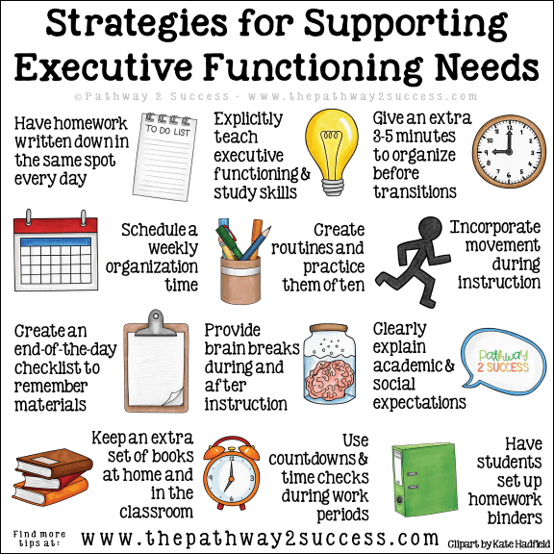
Executive functioning skills are the processes we use in our brain to accomplish daily tasks.
...
Some strategies to strengthen planning skills at home include:
- Plan for a meal. ...
- Plan a trip. ...
- List it out. ...
- Fill the calendar. ...
- Make a daily checklist.

