Colonel Cameron News | Principal ~ Mrs. K. Myers  Secretary ~ Ms. S. Codling  Tel: 519-862-1116  Fax: 519-862-4655 | 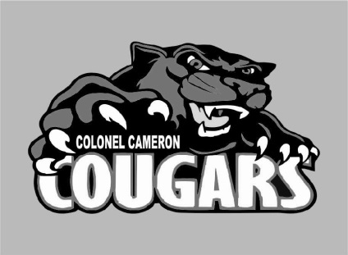
October 2021

Hello Cougar Family! This year has been a start-up unlike any other. We have seen plenty of staff changes and they are still happening. Mr. Steeves was the successful candidate for the Grade 3/4 classroom. This means that we are waiting to hear who our new Resource Teacher will be. Mr. Dark will be moving to PE McGibbon starting Oct 4. We are also waiting to hear who will be filling his job for the remainder of the year. Congratulations to both of them!

School Screening
Please continue to use the online screening tool each day for your child before they come to school. A link to the screener is available on the board website. We want to do our part to ensure the safety of everyone at Colonel Cameron.

Halloween
Colonel Cameron will be celebrating Halloween with Black and Orange day on Friday, Oct 29. Treats are not necessary but if you must send them, please remember that we cannot have ANY homemade treats this year. All treats must be prepackaged and nut free. Homemade treats will be sent back home.

Parent Council
Parent Council will be having an online meeting on 4 October at 4PM. If you would like to join us, please let the office know so that we can send you the invitation to the Google Meet. Parent council is always looking for some fresh faces with fresh ideas!

Socktober!
For the month of October, Colonel Cameron will be celebrating Socktober. Socks are one of the most needed items for shelters, but the least donated. We want to work together to keep feet warm during the winter months. From Oct 1st-22nd, Cougar families are being asked to donate new, unopened socks to our school, which will then be donated to the Inn of the Good Shepherd. Each day we will collect socks from classrooms and keep a tally of how many pairs we are able to donate. Our school goal is 233 pairs. That’s one pair of socks for every student in our school! Let’s rock the socks Cougars!

Important Up-coming Dates:
Oct. 4 – Picture Day
Oct. 4 - School Council Meeting
Oct 6 – Terry Fox Run
Oct 7 – Funky Sock Day
Oct 8 – PA Day
Oct 29 – Black and Orange Day
Oct 11 – Thanksgiving (No School)
Nov 18-19 – Parent Teacher Interviews
Nov 19 – PA Day
Dec. 20-Jan 3 – Christmas Holidays
Jan 31 – PA Day
Feb 21 – Family Day (No School)
March 14-18 March Break
April 15- Good Friday (No School)
April 18 – Easter Monday (No School)
May 23 – Victoria Day (No School)
June 10 – PA Day
June 21 – Native Solidarity Day
June 28 – Last day of School
June 29 – PA Day

Visit the Facebook page, “Colonel Cameron PS- Parent Council” for updates on great things happening at our school!

