Colonel Cameron News  November 2021 | Principal ~ Mrs. K. Myers  Secretary ~ Ms. S. Codling  Tel: 519-862-1116  Fax: 519-862-4655 | 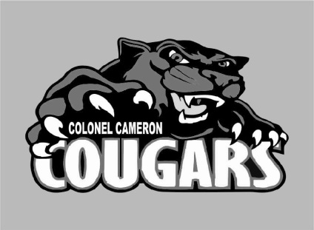
School Screening
Please continue to use the online screening tool each day for your child before they come to school. A link to the screener is available on the board website. Please note that if one child is waiting for the results of a COVID test then none of the children in the family are to attend. We want to do our part to ensure the safety of everyone at Colonel Cameron.

Late Arrivals
Please make sure that students that arrive after the bell go to the front door for a late check-in. Because our outside doors need to be locked, students can’t get in after 9 and teachers can’t always see them outside. With the colder weather coming we don’t want anyone left out there.

Socktober
Thank you to everyone that participated in our Socktober event. Our goal was to collect 233 socks for the Homeless Shelter and thanks to your generosity, we collected over 900 pairs! What an amazing way to show our community that Cougar Families care.

Nut Allergies/ Food Sharing
We do have students in school that have nut allergies. Please help us keep our school safe for them by not sending peanut products to school. This includes Nutella and Wow Butter products. This will be especially true if you choose to send in treats for Halloween (Black and Orange Day). Also note that due to COVID protocols, homemade treats may NOT be sent in for sharing. Any homemade treats will be returned home.

School Cash Online
If you haven’t already registered for School Cash Online, please try to get this done as soon as you can. Fundraisers, school events and other events that require cash transactions will go through School Cash Online ONLY. If you need help setting it up, please let Ms. Codling know.

Special Food Days
We are in the process of looking at starting food days up again. There are several companies that are willing to work with us to help us ensure that we are meeting all COVID protocols to make it happen. Watch for more information to come out. Note that Special Food Day orders can only be placed through School Cash Online. If you order for your child and they are away that day, please make arrangements to come in and pick up their food or let us know who to send it with. Food orders cannot be kept at the school.

Parent Teacher Interviews
Parent teacher interviews will be held on the evening of the 18th and during the PA Day on the 19th. Please watch for more information coming out soon.

Parent Council
Parent Council will be having an online meeting on 22 Nov at 4PM. If you would like to join us, please let the office know so that we can send you the invitation to the Google Meet. Things continue to be different, but Parent Council continues to work hard to help make a difference here at Colonel Cameron and we appreciate all they do.
The executive this year is: Co-Chairs: Justin Randall Amber Passingham
Secretary: Jen Dawson
Treasurer: Angela Gibbs
Fundraising: Group Effort
Parent Council Facebook: Angela Gibbs
The current Fundraiser is the Big Box of Cards. Your child should have brought home a flyer and Ms. Codling sent out an email. The cards will arrive the week of November 15th. Please reach out to Parent Council or the school if you need more information. We have 2 boxes that were donated by the company that will go to the top 2 selling families!

Important Up-coming Dates:
Nov 5 – Colour House Day
Nov 11 – Remembrance Day (Dress in black and red)
Nov 12 – Progress Reports go home
Nov 18-19 Parent Teacher Interviews
Nov. 19 – PA Day
Nov 22- Parent Council Meeting
Nov 26 – Creative Hairstyle Day
Dec. 20-Jan 3 – Christmas Holidays
Jan 31 – PA Day
Feb 21 – Family Day (No School)
March 14-18 March Break
April 15- Good Friday (No School)
April 18 – Easter Monday (No School)
May 23 – Victoria Day (No School)
June 10 – PA Day
June 21 – Native Solidarity Day
June 28 – Last day of School
June 29 – PA Day

** Print off the picture below or have your student draw and colour a fall picture. Have them deliver it to the office for a chance to win a prize! **

Visit the Facebook page, “Colonel Cameron PS- Parent Council” for updates on great things happening at our school!

