Colonel Cameron News | Principal ~ Mrs K. Myers  Secretary ~ Ms. S. Codling  Tel: 519-862-1116  Fax: 519-862-4655 | 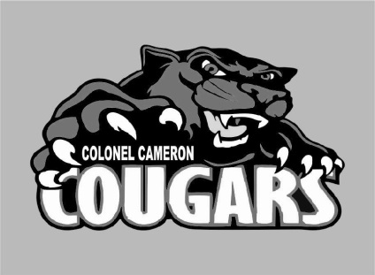
March 2021

Get Ready for Picture Day!
Picture day is March 11. This will be for all students. Graduating students should note that this is also Grad Picture day. Retakes will be scheduled for a later date.

Kindergarten Registration is still open!
Registering your child for Kindergarten is as easy as 1, 2, 3.
1. Find your school.
2. Complete the online registration form @ www.lkdsb.net/kindergarten
3. The school will contact you with a day and time to bring in your documentation as soon as we are given the okay to do so. Please make sure that you share this information with families of young children.
If you know of any
families that might be moving into our area in the next year, please have them call the school. Knowing these numbers in advance can help us do better class planning for next year.

March Break Moved
Please note that March break has been moved into April. Classes will run as normal the week of March 15-19.

Parking

We continue to have issues with people parking in our circle out front. Please park in the parking lot so that our students can walk through the front safely. This is a fire zone and should be used as drop-off only.
DO NOT park in the Bus Loading area at any time. We have buses that need to safely load and unload students quickly and then get to their next drop off.

Parent Council
The next meeting is April 26. If you would like to join us, please let Mrs. Myers know.
Parent council is hosting a couple of fundraisers right now. Information came home through email about a seed fundraiser. These seeds can be ordered online and delivered directly to your home and then the proceeds come directly to Parent Council in support of materials for the school.
The second fundraiser is a Barn Board Painting. Again, the information came home through email. These orders can be placed through School Cash Online.
These are great opportunities for you to support Parent Council and help them support our school.

Morning Supervision
Please keep in mind that there is no supervision before 8:45. Students should NOT arrive at school prior to this for safety reasons.

Playground Equipment
Although the weather is starting to hint at Spring, the playground equipment is closed until it is inspected by an outside agency to ensure that it hasn’t sustained any damage over the winter. If your children are visiting the school property after hours, kindly remind them to stay off the equipment until we notify families that it has been inspected.

Important Up-coming 2020-2021 Dates:
April 2 Good Friday
April 4 Easter Monday
April 12-16……… Spring Break
April 26 ……….. Parent Council
Meeting
May 24 Victoria Day
June 4 PA Day
June 28 Last Day of School

