Colonel Cameron News  December 2020 | Principal ~ Mrs. K. Myers  Secretary ~ Ms. S. Codling  Tel: 519-862-1116  Fax: 519-862-4655 | 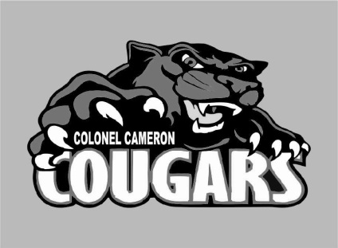

School Screening
Please continue to use the online screening tool each day for your child before they come to school. A link to the screener is available on the board website. We want to do our part to ensure the safety of everyone at Colonel Cameron.

Automated safe arrival calls
December 2, LKDSB will be implementing an automated attendance messaging system for Elementary schools. The system will notify parents/guardians that your child has been marked absent and the school does not know the reason. We will contact the parent’s /guardian’s phone numbers and emails that you have provided and ask that you call the school to confirm the absence and provide the reason. You can help by ensuring that the school has your most updated contact information and by notifying the school office in advance if your child will be late or away. Our answering machine will take your message any time of day or night.

Language support
Lambton Public Library offers some free online resources for families. Reading with your child is important but finding a book isn’t always easy for some families. Tumblebooks is one of the free resources. This is a collection of books that are read online. Check it and some of the other free resources out at https://www.lclibrary.ca/en/learn/early-learning.aspx

Parent Council
Parent Council will be having an online meeting on 3 Dec at 4PM. If you would like to join us, please let the office know so that we can send you the invitation to the Google Meet. Just like everywhere else, things are different but Parent Council is working hard to help make a difference here at Colonel Cameron and we appreciate all they do.
The executive this year is: Co-Chairs: Angela Gibbs and Justin Randall
Secretary: Amber Passingham
Treasurer: Sarah Needham
Fundraising: Group Effort
Parent Council Facebook: Angela Gibbs

Parking/Drop Off
Thanks for being so diligent about parking in the parking lot if you are leaving your vehicle. This
allows for quick movement of cars that are just dropping off and allows cars that are moving through the ability to see students that might be walking through the lanes. We appreciate you helping keep your students and their friends all safe! Please help us in the afternoons as well by NOT parking in the front lanes. If you are pulling in there, please stay with your car so that you are not blocking others in. This is also a fire route and should there be an emergency we need you to be able to move your vehicle quickly.

Holiday Spirit
Unfortunately, we will not be having our Christmas Dinner this year. My hope is that we all stay safe this year and next year we will appreciate that time together more than ever. I know that the days leading up to the holidays are favorites for the kids to bring in food to share with their friends. Please note that any food brought in to be shared will need to be sent back home. We appreciate your thoughtfulness, but we need to keep the safety of everyone front and center.
We will be having Holiday Day on Dec 18. For this day, students are encouraged to come to school decked out in their holiday wear (hats, sweaters, socks etc.).

Important Up-coming Dates:
Dec 3 – Parent Council Meeting
Dec 18 – Holiday Spirit Day
Dec. 21-Jan 3 – Christmas Holidays
Feb. 2 – PA Day (Note this is a Tuesday)
Feb. 15 – Family Day (No School)
Mar 15-19 – March Break
April 2- Good Friday
April 5 – Easter Monday
May 24 – Victoria Day
June 4 – PA Day
June 28 Last Day of School

Visit the Facebook page, “Colonel Cameron PS- Parent Council” for updates on great things happening at our school!

