Colonel Cameron News | Principal ~ Mrs K. Myers  Secretary ~ Ms. S. Codling  Tel: 519-862-1116  Fax: 519-862-4655 | 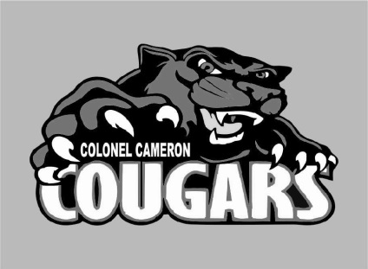
April 2021

March Break Next Week
Next week is our Spring Break. Please make sure that you don’t send your child to school.

School Pictures
If you are interested in ordering pictures from Picture day, please order them online directly through LifeTouch. Retake day is the 23rd. If you want pictures retaken, please let your child’s teacher know.

Kindergarten Registration is still open!
Registering your child for Kindergarten is as easy as 1, 2, 3.
1. Find your school.
2. Complete the online registration form @ www.lkdsb.net/kindergarten
3. The school will contact you with a day and time to bring in your documentation as soon as we are given the okay to do so. Please make sure that you share this information with families of young children.
If you know of any
families that might be moving into our area in the next year, please have them call the school. Knowing these numbers in advance can help us do better class planning for next year.

Parking

We continue to have issues with people parking in our circle out front. Please park in the parking lot so that our students can walk through the front safely. This is a fire zone and should be used as drop-off only.
DO NOT park in the Bus Loading area at any time. We have buses that need to safely load and unload students quickly and then get to their next drop off.
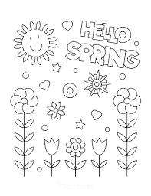

Parent Council
The next meeting is April 26. If you would like to join us, please let Mrs. Myers know.

Morning Supervision
Please keep in mind that there is no supervision before 8:45. Students should NOT arrive at school prior to this for safety reasons.

Playground Equipment
Although the weather is starting to hint at Spring, the playground equipment is closed until it is inspected by an outside agency to ensure that it hasn’t sustained any damage over the winter. If your children are visiting the school property after hours, kindly remind them to stay off the equipment until we notify families that it has been inspected.

Important Up-coming 2020-2021 Dates:
April 2 Good Friday
April 4 Easter Monday
April 12-16……… Spring
Break
April 21………... Silly Hair Day
April 26 ……….. Parent Council
Meeting
May 24 Victoria Day
June 4 PA Day
June 28 Last Day of School

