Colonel Cameron News | Principal ~ Mrs. K. Myers  Kathy.myers@lkdsb.net  Secretary ~ Ms. S. Codling  Sharon.codling@lkdsb.net  Tel: 519-862-1116  Fax: 519-862-4655
September 2021

Welcome Back!

Welcome to our returning Colonel Cameron Cougars and welcome to our new students and families who have joined us this year. I’m excited to get to see the kids back in school soon. Hopefully everyone is looking forward to a great 2021-2022 school year after enjoying a fun and relaxing summer break. Although COVID is still changing the way that we will do certain things at school, it is promising to know that some things are starting back up, like clubs and sports. Our students and staff have proven that they can handle whatever the year throws at us and be successful, but of course our fingers are all crossed that we are here in school all year long.
Again, this year, students will not be on the playground in the mornings. Students will come in their assigned doors and go directly to their classroom. If possible, please wait until close to 9 to drop your children off to help with this. If on the first day you’re not sure what door that is, I will be out front of the school to help guide students and of course to say hello!

We are excited to begin a new school year that promises to be a year of learning and growth for all. Together we strive to continuously improve the educational opportunities available to all students. At Colonel Cameron Public School, we look forward to working with each child and family to ensure an excellent education for Every Student, Every Day.

School Hours

8:45 … School Entry
9:00 Classes Begin
9:00-11:00 Instructional Time
11:00-11:40… Nutrition Break/Recess
11:40-1:20 Instructional Time
1:20-2:00 Nutrition Break/Recess
1:40-2:00 Recess
2:00-3:20 Instructional Time
3:20 Dismissal

Staff Members at Colonel Cameron:

Ms. T. Miller FDK
Mrs. J. McLaughlin SK/1
Mrs. C. Buchner Gr. 1/2
Ms. L. Vlcek Gr. 2/3
Mrs. S. VanHooft……………………………………………… Gr. 3
Mr. M. Dark Gr. 4/5
Mrs. M. Schenck……………………………………………….Gr. 5/6
Mr. G. Core Gr. 6/7
Mr. A. Nicholson Gr. 8
Mr. Scott Steeves Resource
Mme. L. Harrison French/Arts
Mrs. J. Petrucci Prep
Mrs. L. Budgell-Larocque Prep
Mrs. E. Osborne Educational Assistant
Mrs. L. Denning………………..……...……. Educational Assistant
Ms. J. Chalcraft Educational Assistant
Mrs. S. Sowinski Early Childhood Educator
Mrs. B. Alderman Custodian
Mrs. Ward Custodian
TBD Custodian
Ms. S. Codling Secretary
Mrs. K. Myers Principal

Important Up-coming Dates:
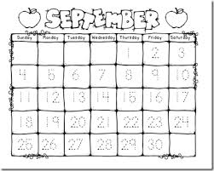
Sept 7…..…..First day for Students in SK-8
Sept 8….. First day of school for some JK’s
Sept 9..…..First day of school for other JK’s
Sept 10………………… All students attend
Sept. 21………….…Snack Program begins
Sept. 30……………….…. Orange Shirt Day
Oct 8……………………….…………PA Day
Oct 11 ….………………………Thanksgiving
Nov 19…………………..………..….PA Day
Dec. 20-Jan. 3 ……….…..…………Holidays
Jan 31 ……………………………….PA Day
February 21……………….. ……..Family Day
March 14-18……………………. March Break
April 15……………….…………. Good Friday
April 18…………………….… Easter Monday
May 23………..………………… Victoria Day
June 10……………………………….PA Day
June 29………………….. Last Day of School

Leaving School at Lunchtime
Students may leave the school to go home for lunch this year. They will leave at second break and should have a note from their parents/guardians.

Parents and Visitors

To maintain a safe and healthy learning environment for our students and greater school community, all visitors and parents must enter through the front doors and sign in at the office. Please note that only one visitor should be in the office at a time. Thank you in advance for your cooperation.

School Advisory Council
School Advisory Council is made up of a group of parents, teachers, and a community representative who meet during the school year for the purpose of providing positive input to the principal on school-related educational issues. Council meetings are open to all members of the school community. Please watch for information about our first meeting.
Subsection 4 (4) of O. Reg. 610/00 states that an election for the current year’s school advisory council will be held “during the first 30 days of [the] school year, on a date that is fixed by the chair or co-chairs of the school council after consulting with the principal of the school.” If you are interested in a position, or just joining us to be part of the conversation, please email Kathy.myers@lkdsb.net or phone the school to express your interest.

Milk Program
Our milk program will be continuing but we aren’t sure of a start date yet. Please watch for more information.

Allergy Alert
Please be advised that Colonel Cameron is a Nut Aware school. We have students and staff with life-threatening allergies to certain
foods and scents. We ask that the following products not be sent to school:
- Peanuts and all nuts
- Foods containing nuts
- Soya peanut butter, WOW Butter, etc.
- Shellfish
- Scented products (cologne, perfume, etc.)
Prevalent Medical forms were sent home with report cards in June. Please return those to the school by the end of the month. If you need one, please let us know and if your child has out-grown their condition, please also let us know that.

Medication
If your child needs prescription medication administered during school hours, please contact the office for an “Authorization for the Administration of Oral Medication” form. It must be completed by the parent/guardian and physician and forwarded to the Principal for each school year. Over-the-counter medications (e.g., Tylenol, Advil) will not be administered by staff and should not be sent to school.

Student Absences
Regular school attendance is extremely important to the success of all students. As difficult as it can be some days, starting the school day on time is important.
Our Safe School Policy requires that parents or guardians notify the school through the School Messenger App if students will be absent or late. (Directions on how to set up the app are included on the next 2 pages)
It is essential for safety reasons that we are aware if your child is not at school. If we have not heard from you, a telephone call will be made by the school secretary for follow-up on the absenteeism. Late students need to report to the office before going to class. We appreciate everyone’s cooperation

School Messenger Quick Reference Guide

How to sign up and create a SchoolMessenger account.
- Open an internet browser and search for go.schoolmessenger.ca or download the BLUE SchoolMessenger app
Click to Download the app for Apple devices. Click to Download the app for Android devices.

- Click Sign up in the upper right corner

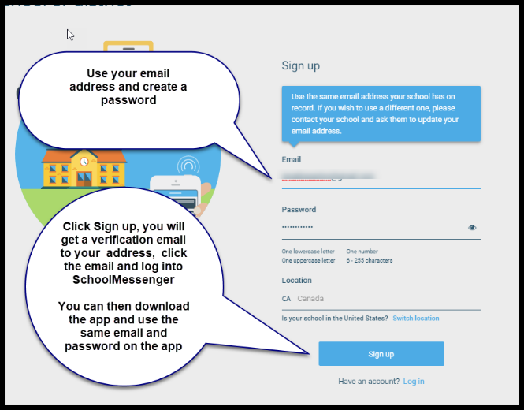
- Use the email address on file at the school and create a password. Important note: You must use the same email address your school has on record. If you wish to use a different one, please contact your school and ask them to update your email address.

- Click Sign up. Choose your password. Select Location as Canada. Tap Sign Up. You will receive a verification email. From this email, click the link to verify. This will open in a browser where you will be prompted to enter your login details. Log in and confirm your details.

Phone Access and Setting a PIN
If using the LKDSB toll-free Attendance Reporting number 1 (844) 487-3695, Parents/guardians should require that a Personal Identification Number (PIN) be entered before absences can be reported or explained for their student using the SafeArrival phone system.

What if I’m not calling from my home phone number?
You will be asked to enter a phone number that is registered for your student.
Can anyone who knows my phone number report an absence using the phone system? Including my child?
Yes, anyone who uses a phone that is listed in the school’s system for your student or anyone who can enter a phone number that is listed in the school’s system for your student can report an absence for your student.
It is strongly recommended that you set a PIN that must be entered before an absence can be reported or explained for a student. We recommend that you provide your email address so that whenever

an absence is reported or updated, you will receive an email conﬁrmation notice.

Setting a PIN
PIN settings can be set by Parents/ Guardians from the Attendance page of the SchoolMessenger app or by logging into the School Messenger Website.
On the Manage your PIN Settings screen, choose the district in which the student is enrolled (if the Parent Guardian has students enrolled in more than 1 district). The Parent / Guardian will see a list of his/her students and will be able to tap the checkbox to request that a PIN be required for when reporting and explaining absences for this student by phone. A 4-digit PIN can then be entered. Changes made on this screen will be saved automatically. Tap the eye icon to see the PIN as you enter it. Tap the edit icon to modify the PIN.

