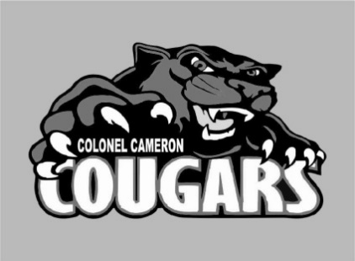
Colonel Cameron News
Principal ~ Mrs. K. Myers
Kathy.myers@lkdsb.net
Secretary ~ Ms. S. Codling
Sharon.codling@lkdsb.net
Tel: 519-862-1116
Fax: 519-862-4655
November 2022

Remembrance Day
Thanks to Mr. Steeves and other staff members, we will be hosting a full Remembrance Day Assembly at our school on November 11th. Please feel free to join us. Watch your emails for an update with the time that our service will be starting. Students are encouraged to bring some loose change to school on the 11th to support the Poppy Campaign.

Holidays
We want to do our best to be inclusive of all celebrations that have meaning to our families. If you have a holiday that your family celebrates that we might not be aware of or that wouldn’t traditionally be celebrated at school, please reach out and let us know. Also, if English is not your first language in your home, we would also like to know that.

Important Up-coming Dates:
Nov 7…………….… McMillan Orders Due
Nov 7 ………………. Picture Retake Day
Nov 7-11……………….…….. Treaty Week
Nov 11 ……… Progress Reports go home
Nov 11……………….. Black and Red Day
Nov 11…………..…. Pizza Hut Lunch Day
Nov 17 & 18…. Parent Teacher Interviews
Nov 18…………………..………..….PA Day
Nov 24……………………………. Twin Day
Nov 29…………………... Orange Shirt Day
Nov 30….… Grade 8 Burns Delivery today
Dec. 26-Jan. 8 ……….…..…………Holidays
Feb 3 ……………………………….PA Day
Feb 20……………………... ……..Family Day
March 13-19……………………. March Break
April 7……………….…………. Good Friday
April 10…………………….… Easter Monday
April 28………………………………. PA Day
May 22………..………………… Victoria Day
June 9……………………………….PA Day
June 29………………….. Last Day of School

Parents and Visitors

To maintain a safe and healthy learning environment for our students and greater school community, all visitors and parents must enter through the front doors and sign in at the office unless you are visiting for a large planned event such as Parent/Teacher interviews. Thank you in advance for your cooperation.

School Advisory Council
School Advisory Council met on the 27th of September. The elected officials are:

Thank you to everyone that supported the Apple Fundraiser. Upcoming will be Spirit Wear, Pralls Poinsettias and LaPier’s Wreath making. Watch your emails for further information.

Milk, Popcorn and Special Food Days
Milk and popcorn sales are up and running. If you have decided that you would like one of these for your child, feel free to go to School Cash Online to make your purchases. Ms. Codling checks the list once a week for any students that need to be added to the list.

Special Food Days are also up and running. Know that if your child is away during a special food day and you have made a purchase, you will need to arrange to have the food picked up at the school that day. Refunds will not be given.

