Colonel Cameron News | Principal ~ Mrs K. Myers  Secretary ~ Ms. S. Codling  Tel: 519-862-1116  Fax: 519-862-4655
March 2022
School Screening
Please continue to use the online screening tool each day for your child before they come to school. A link to the screener is available on the board website. Please note that if one child is waiting for the results of a COVID test or if one child fails the screener then none of the children in the family are to attend. We want to do our part to ensure the safety of everyone at Colonel Cameron.

Kindergarten Registration
Did you, or do you know someone that missed our January Kindergarten Registration? It’s not too late. Follow the steps below to register. We will be hosting opportunities for the children to come and visit in April and again in June.
Registering your child for kindergarten is as easy as 1, 2, 3.
Follow the steps below to register a student in JK to Grade 8 who is new to LKDSB.
- Click here to find your local Public School and check on Bussing
- Sign up for an LKDSB Parent/Guardian account in our secure Aspen Student Information System and follow the steps to register an Elementary student who is NEW to LKDSB. This account is meant to be created by a Parent/Guardian. A valid e-mail address is required to verify your identity when requesting an account.
Click here for instructions on how to create an LKDSB - Aspen account. Once the account is created, you will be able to login to the LKDSB Online Registration process.
Click here to Login to LKDSB - Aspen or to Request an LKDSB - Aspen account to register your child
Call the school to make an appointment to visit your school to meet our caring staff and complete the registration process.
To complete your registration, remember to bring:
  - Birth certificate or proof of Canadian Citizenship or Residency Status (if appropriate)
  - Proof of Residency (e.g. utility or tax bill, a lease/rental agreement, a proof of ownership, landline phone bill, etc.)
  - Parent contact information, work and home phone, e-mail
  - Emergency contact information
Immunization Requirements - The Ministry of Education requires that every student have a complete and up-to-date immunization record on file with the local Health Unit in order to attend school. Contact Chatham-Kent Public Health or Lambton Public Health to ensure your immunization records are up-to-date.​

Food Days
Food days are starting up again. Our first food day will be Boston Pizza on March 11th. Orders are available through School Cash online.

Parent Council
Our next Parent Council meeting will be May 9, 2022. Please let the office know if you would like to be invited to the Google Meet. Parent Council has the McMillan’s Cookie/Muffin Mix Fundraiser on the go. The orders should be returned to the school by March 8. Late April will see the start of an Epicure Fundraiser. Watch for more information coming!

Important Up-coming Dates:
March 4 – Colour House Day
March 11 – Boston Pizza Lunch
March 14-18 March Break
March 25 – Spring is Here! Wear something green or with flowers on it.
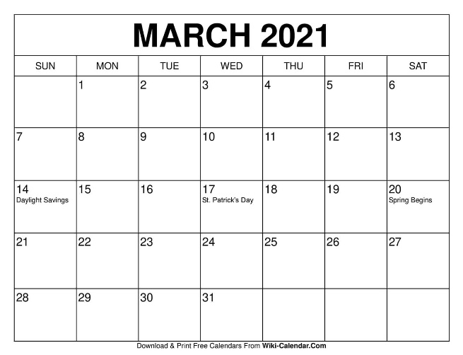
April 1 – April Fool’s Mixed up Colour House day. Wear another colour house colour to get points for your colour house.
April 15- Good Friday (No School)
April 18 – Easter Monday (No School)
May 23 – Victoria Day (No School)
June 10 – PA Day
June 21 – Native Solidarity Day
June 28 – Last day of School
June 29 – PA Day

Home Help
Here are some games to help develop executive functioning skills:

BLURT
Skills: self-control, metacognition

How to Play: In this game, the parent reads a definition of a word and kids have to figure out the word itself. For example, a question might be, “What is a partially dried grape?” When the student answers “raisin”, they win that turn. If more than one child is playing at a time, read the card and whoever “blurts” the answer first, wins. The idea is that only the kids playing can blurt out, and everyone else must have self-control, even if they know the answer. This is great for a review before a test!

SCRABBLE
Skills: planning, organization

How to Play: In scrabble, kids use random letters to build words and keep score as they go. Play in small groups and even partner kids together who may need extra support with spelling or language. Planning and organization is required because kids need to build off of each others’ words as the game progresses. As an extension, have kids look up definitions to the words they create or use the word in a sentence before points are scored.

