Colonel Cameron News | Principal ~ Mrs K. Myers  Secretary ~ Ms. S. Codling  Tel: 519-862-1116  Fax: 519-862-4655
April 2022
School Screening
Please continue to use the online screening tool each day for your child before they come to school. A link to the screener is available on the board website. We want to do our part to ensure the safety of everyone at Colonel Cameron.

Kindergarten Registration/ New Students
Did you, or do you know someone that missed our January Kindergarten Registration? Do you know someone that is moving into our area and has school-age children? It’s never too early to register. By filling out the paperwork now, you are letting us know your intentions for September. This in turn, helps us get our numbers right for September which then means that there is less of a chance of us needing to reorganize classes after they have started. Parents of JK students that are registered will have their students invited to some activity days coming up.

Food Days
Our food days this month are Little Caesars Pizza on the first and Foodland on the 29th. Remember that orders must be placed through School Cash Online. POPCORN is back starting April 8! Popcorn will be available on Fridays at second lunch. Orders must be placed through school cash online and will work like the milk orders.

Family Movie Night
We are so excited to be hosting our first movie night at Colonel Cameron since February 2020! We will be hosting this evening of fun on Thursday, April 14th. We will be watching the 2022 movie, SCOOB! We are so grateful for the wonderful turnout of families during our past events. The proceeds from food sales will be invested in materials and equipment that will benefit all students. Please bring blankets or chairs to sit on, ensuring that chairs will not damage the gym floor. No outside food will be permitted. Pajamas are encouraged! Please check your email for more information.

Parent Council
Our next Parent Council meeting will be May 9, 2022 we will be meeting in person but will try to have a link available if you need to join us online. Please let Mrs. Myers know by that morning if you need the link. McMillan orders will be in April 11. Please watch for more information about pickup.

Important Up-coming Dates:
April 1 – April Fool’s Mixed up Colour House day. Wear another colour house colour to get points for your colour house.
April 1 – Graduation Photo Day
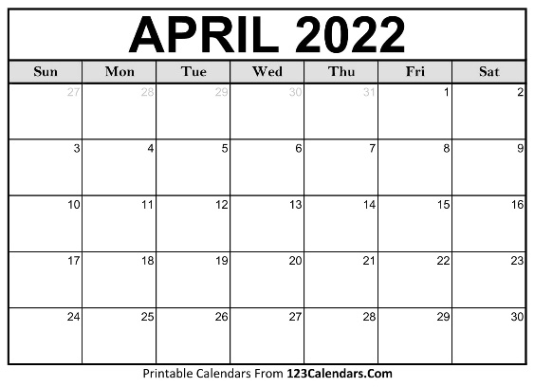
April 14 – Wear bunnies and spring colours
April 14 – Family movie night
April 15- Good Friday (No School)
April 18 – Easter Monday (No School)
April 20 &21 – Kinderstart (Part 2)
April 29 – Colour House Day
April 25 – Spring Photo Day
May 23 – Victoria Day (No School)
June 10 – PA Day
June 21 – Native Solidarity Day
June 28 – Last day of School
June 29 – PA Day

Home Help
Here are some games to help develop executive functioning skills:

PICTIONARY
Skills: flexibility, time management
How to Play: This game has students drawing phrases on paper or a whiteboard that others must guess correctly. Kids need to use time management to best draw their phrase before the time is up. This is such a fun game! I even love taking pictures of some of the drawings that are both hilarious and amazing.

DISTRACTION
Skills: working memory, attention
How to Play: In this card game, kids work on remembering numbers given to them while encountering distractions, including questions they have to answer. It is a great activity to teach about distractions that can throw us off!

5 SECOND RULE
Skills: time management, task initiation
How to Play: Kids must name 3 things that fit a given topic. For example, kids might need to name 3 professional basketball teams or 3 pieces of jewelry. The categories differ greatly so kids have to be on their toes.

FREEZE
Skills: self-control, attention
How to Play: Freeze is a game where you play music and allow kids to be silly and dance. Then, at any moment, say “Freeze!” and kids need to stand completely still. It takes a lot of self-control to stop dancing to a song you’re into!

