Dear Parents/Guardians and Staff:

This letter is notification of a second confirmed case of Novel Coronavirus (COVID-19) in your school community. As this second case is in the same cohort as the previous case, Chatham-Kent/Lambton Public Health has declared an outbreak. An outbreak is declared when there are two or more cases in a school community, where at least one case could have reasonably been acquired in the school setting. If any additional individuals need to be isolated, they will be contacted by letter or telephone by Chatham-Kent/Lambton Public Health. If you have not been notified (either by letter or telephone call), your child has not been in close contact with the confirmed case.

It is important that you complete the province's COVID-19 Daily Screening Tool for students and staff each day before your child attends school. To access the daily screening tool go to: https://covid-19.ontario.ca/school-screening/

If your child presents one or more symptoms of COVID-19, they cannot attend school until they receive a negative COVID-19 test result; is cleared by public health; or is diagnosed with another illness by a Health Care Provider.

Symptoms of COVID-19 include: fever or chills; cough or barking cough (croup); shortness of breath; decrease or loss of taste or smell; nausea, vomiting, and/or diarrhea. If you or your child has any one or more of these symptoms, your child must not go to school. Household members who are not fully vaccinated should only leave the house for essential purposes.

If you are unsure about when your child can return to school, speak with your health care provider or contact public health.

Additional information about COVID-19, including symptoms and recommendations for preventing and controlling the spread of the virus, is available in the attached fact sheet.

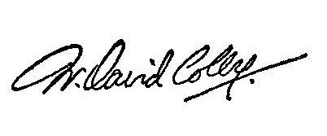
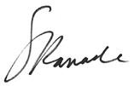
Sincerely,

Dr. David Colby MSc, MD, FRCPC Medical Officer of Health
CK Public Health
Attachment(s)
Dr. Sudit Ranade, MD, MPH, MBA, CCFP, FRCP(C) Medical Officer of Health
Lambton Public Health

CK Public Health Grand Office
435 Grand Ave. W, Chatham ON N7M 5L8 Tel: 519.352.7270 Fax: 519.352.2166 Clinic Services
177 King Street East, Suite 2, Chatham ON N7M 3N1 Tel: 519.355.1071 Fax: 519.355.0848 www.ckpublichealth.com

Lambton Public Health
160 Exmouth St., Point Edward ON N7T 7Z6 Tel: 519.383.8331 Fax: 519.383.7092
Email: publichealth@county-lambton.on.ca www.LambtonPublicHealth.ca

