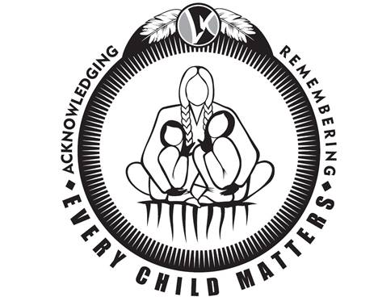
National Day for Truth and Reconciliation – Orange Shirt Day – September 30th
The Government of Canada has formally designated September 30th, National Day for Truth and Reconciliation, as a federally statutory holiday for employees in the federal government and federally regulated workplaces. This day will be observed to honour First Nations, Inuit and Metis survivors and their families and communities, and ensure the public commemoration of their history and the legacy of residential schools.

The Lambton Kent District School Board will commemorate the impact of residential schools on Friday, September 30, 2022 – Orange Shirt Day. Students and staff are encouraged to wear orange shirts and use this day as a catalyst to encourage learning and understanding about the residential school system and the impacts that system has had on First Nations, Metis and Inuit people. This is a meaningful way as school communities to come together in a spirit of reconciliation and hope because “Every Child Matters”. Respectfully, flags at all LKDSB schools and facilities will be lowered on this day.

This recognition day will be part of the activities and discussions occurring during the Truth and Reconciliation Week September 26th to September 30th which will also include discussions about the truth of Indigenous treaties, languages and culture and First Nation, Metis and Inuit land claims.

In honouring and remembering those impacted by residential schools, LKDSB had commissioned a new orange shirt design in 2021. Orange shirts are available for order by interested staff and students from Screenart, a company in Wallaceburg. Screenart has created an online store for LKDSB orders, therefore staff and families will submit payment online directly to Screenart. The store is open immediately for purchases, and will remain open until Friday, September 9th with all shirts ordered delivered to the schools via the board courier by September 29th. Shirts can be order through the following link https://www.screenart.ca/lkdsb_ecm/shop/home.

This is time sensitive, so orders will only be accepted online until Friday, September 9th, 2022.

