Lambton Centennial Paint Night Out!
Please join us for a fun-filled adult night out!
On Thursday, December 7th from 6-9pm in the Centennial gym, Bundles Creative Creations will be helping us paint some wonderful signs just in time for Christmas!
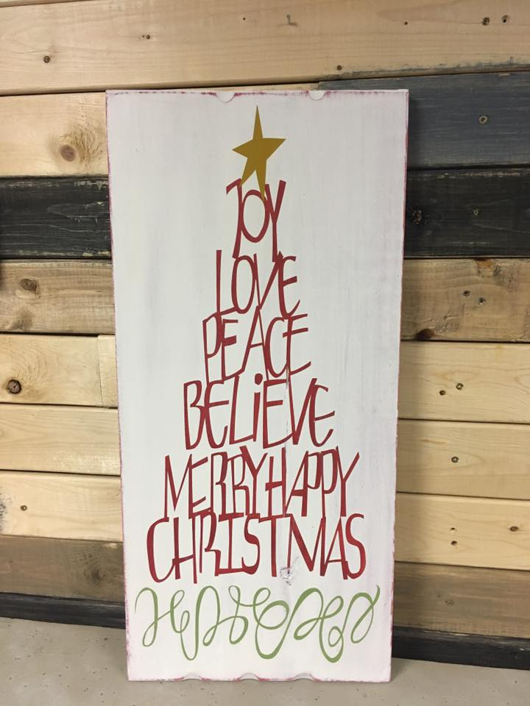
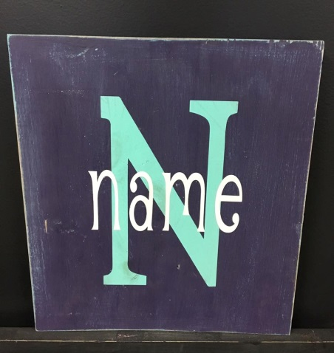

*Don’t worry, no artistic talent is required because stencils are used!*
Sign up for 1 of 2 options:
A. Christmas sign ($55+tax) or B. Name sign ($25+tax)
To register, go to www.mybundles.ca or call the shop @ 519-204-5954.
Deadline to register is November 30th. Proceeds go to Lambton Centennial School

